School of Computing

Teesside University

Web Development Project

Client brief

Kay Elloway, n3010463

Norman Alexander Opie, n3136749

Steve Walker, n3266475

Adrian Lastovicka, n3284646

Ryan Brewer, n3133818

CONTENTS

School of Computing i
Teesside University i
Web Development Project i
Kay Elloway, n3010463 i
Norman Alexander Opie, n3136749 i
Steve Walker, n3266475 i
Adrian Lastovicka, n3284646 i
Ryan Brewer, n3133818 i
1 Introduction 2
2 Project plan 3
3 Statement of Purpose 5
4 Quality Plan 6
5 Audience Definition 7
6 Marketing Analysis 9
7 Content Analysis 11
8 Moodboard, storyboard and navigation chart 12
9 Testing plan 18
10 Group Evaluation 19
APPENDIX A 20
Desktop site 20
Mobile site 20

Introduction

In this report we will be talking about the process of the prototype website we will be creating for the NextGen even happening at Teesside University. We will be talking about what things will be included in the website and how we will make it accessible for all abilities. Also we will include the finished products which will be attached as appendix A.

Project plan

This was our current project plan as we were working through the document.
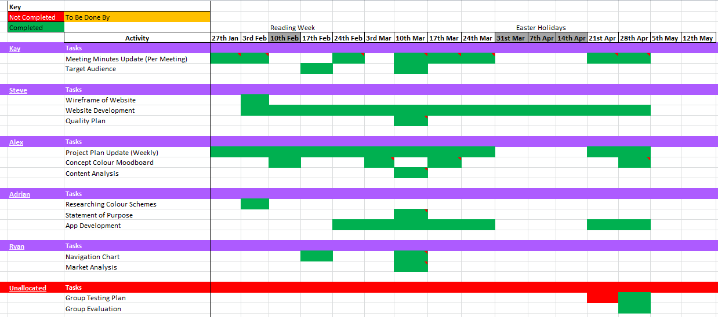

Statement of Purpose

Purpose of the website
The intended primary intents of our NextGen website are to introduce students and potential employers to the purpose of the event (which is to provide an opportunity for students to present their work to each other and to potential employers,)
To clearly show the location and the directions to the event, to provide an overview and preview of students’ work on the portfolio webpage, and also to provide login and administration webpages for students to upload and administrate their work.

The website might also serve the secondary purpose of informing potential future Teesside University students about what they might expect in case they chose to study a course at the University’s School of Computing.

Primary audience
Our intended primary audience are the University’s 1st and 2nd year students (evaluating each other’s work and learning from each other’s feedback)
And potential employers (overviewing the students’ work and potentially offering short and long term placements.)

Secondary audience
The secondary audience will be the University’s tutors, course leaders, and other members of staff who might happen to attend the event.

Design styles chosen to represent the data
We decided to use a standard webpage layout for most of our webpages, except for the portfolios webpage. We are going to style our portfolios webpage as a grid of clickable portfolio thumbnails, each linked to an individual portfolio webpage (or website).

Technology implemented
We are going to build our NextGen website in two versions: as a standard desktop website, and as a mobile app website viewable on smart phones.

Quality Plan
Quality Goals
- The site will be responsive to all hand held devises.
- Images will be fast loading and shall be progressive and will consist of GIF, PNG and JPG format.
- The site will load in a quick and acceptable time.
- Easy and clear navigation system.
- We will make sure that there are no spelling errors.
- Make a link back to the Home page accessible on every page.
- All video used on the site will be thoroughly checked against all top browsers and Flash shall be used when needed as a backup.

Reviews
- There will be checks after every document is completed for grammatical errors.
- I will get second opinions on all documents to ensure the highest quality.

Testing
- Regular performance testing at all stages of development is ongoing and will continue until completion.
- Image analyses to ensure the minimal amount of images are being used to aid in the performance of the site.
- Accessibility tests are to continue throughout on all the top browsers including IE7 and up to IE9, Mozilla Firefox and Googles Chrome.
- Ensure different browser platforms won’t face any compatibility issues with video formats used on the website.

Accessibility
- Accessibility testing by W3C Mark-up Validation Service to ensure correct HTML syntax and use of syntax is acceptable to HTML5 standards.
- Make our material accessible to those with physical disabilities or ‘old’ technology.
- A choice of font size will be made available for people with less vision or poor monitors
- Some people cannot read text if there is not sufficient contrast between the text and background, we will introduce contrast ratio.
- Every image has appropriate alternative text as some users may be visually impaired and using a screen reader.

Change Control
- Keep every version of a document

Quality Records
- Any comments of documents will be stored to ensure quality

Audience Definition
Target Audience:

- Main Target Audience
  - First and Second SCM Students
- Secondary Target Audience
  - Potential Employers
  - Teachers and Tutors

We think that the main target audience for this website will be students from the school of computing. We think this because the website will have all the information on the website and it will also have a section for them to upload and showcase their work for tutors and potential employers to look at. This brings me to my secondary audience tutors and potential employers. We feel these are a secondary audience because not only is all the information about the event on the website but also when the student has uploaded their work tutors and employers can look through the work and tutors can give the students feedback and the employers can decide upon who to take up from work placements. This can help the students improve themselves.

User Scenarios:

Students:
“I have found the event very helpful. When I uploaded my work for display last year as a first year student I was really scared that my work would get turned down. I then got an email from the tutor to say I needed to make some minor changes and my work would be fine for upload. After I altered my work and attended the even I got an offer for a placement which really surprised me as I didn’t expect to get one. It has helped me this year and I am doing another placement with the same company for my 3rd year.”
Employers:
“We enjoy going to the event because we can see how the university is preparing the students for the industry and we can look at students work and if there is one we think is particularly good and can be useful for our company we can discuss with the student and the tutor upon hiring the student for a placement. It is good to see such talent from the university coming into our company.”
Accessibility:

For this site we are aiming to make it accessible for people of all abilities. For this reason we are including the following in the creation of the website in order to allow all people to access it.

- Alt Tags – tags for people to see what images are if they can’t see.
- Accessibility Button (for people with disabilities eg. Blindness, deafness)
- Adjust font size
- Print page
- Access for older computers and other devices.

For those with disabilities, the website will include accessibility options including Alt Tags on links and images, along with background adjustments for those who are colour-blind and audio options for those who do not possess sight anymore.
We will also be incorporating a font adjuster in order for people with sight impairments to be able to see any content that they were previously unable to see. Also included in screen adjustments which has not been previously mentioned is colour adjustments. This will help people adjust the content so that it’s more comfortable for them. A few extra features we will be adding including a print page option for people who wish to print the page out or find it easier to read on paper. There will also be a function on the website that allows it to be accessed on older computers and other devices such as tablets. This will help reach out to our target audience. It will also be accessible to all browsers.

Marketing Analysis

University of Newcastle –
The evens page for the University of Newcastle I feel is pretty well laid out, it has split up the events and what’s on into different sections that are clearly defined by the lists underneath as well as the pictures heading the sections. I think this is a good approach, using pictures to head the category then giving minor details in text underneath. It was also pretty was to find on the main page menu as it was clearly displayed on the left hand side vertical menu bar. Of the sites I looked at I feel that this is a good example of how an events page should be done, or laid out.

University of Reading –
Like the Newcastle Uni site I the events page for the Reading University is pretty clear and easy to find. Unlike the Newcastle Uni site it is significantly less graphical, they have chosen to use text only to show their different events which is fine but I don’t feel is quite as effective in todays ‘market’ as the trend seems to be to use graphics to give things that extra level. The colour scheme of the site overall is nice, bending red with white and it also has some grey/black in there too which just works well together. As I mentioned though I do feel this site is slightly let down by its lack of graphics to dress the pages up because in my opinion it’s all well and good having the required information on the page but if it’s not displayed in the proper ways some of it may get lost. In this day and age I don’t think you can afford to have too much text at once or risk losing peoples interest/attention.

University of Nottingham –
The Nottingham University was one of those that I looked at which was lower down on the scale design. The events page was not hard to find but it was not at first really obvious where it was. The other factor of for my distain for it was its lack of events altogether, there was one. I didn’t think the look of the website was much of a redeeming quality either. It was plain and the colours used were hardly inspiring but If there was one positive I could draw from this I could at least say that they were well matched. That for me was pretty much the only good thing about the website at all. I would take little inspiration from this example, if any at all.

University of Manchester –
This university’s page was okay, it was overall probably the second best one that I’d looked at. For a start it was fairly simple and straightforward to find on the homepage of the university itself which was good, certainly better than some of the others. Secondly It was well laid out, free from loads of clutter and unnecessary things surrounding. Its use of graphics to illustrate the events was a plus too for me as well as the really nice colour scheme which combined a nice shade of purple on a white backdrop which went together really nicely. Not too bold and not too subtle either.

I think overall out of the websites I looked at I think that Reading’s university site was the best and I think that Nottingham’s was the worst. I think there are things that can be taken from the Reading example for sure. I consider that to be a well-designed site/page on which the colour scheme, text and graphics go together well and complement each other fairly nicely. On the other end of that scale the Notting site didn’t really have any of this.

The one thing that I noticed from researching other universities websites and events pages was the fact that none of them seemed to do the same kind of thing that was the focus of our task, which I thought was surprising .

Content Analysis
As far as what content will be included on the website is concerned, the main priority is to bring forward information that is relevant to our main target audiences and place that relevant content into the appropriately designated pages. Such information relevant to our main target audiences (1st and 2nd Year Students) will include the basics of what they will be gaining, such as the potential employment of those students that can be gained as a result of the event, the general expectations of those viewing students work and possibly even the persuasion of allowing the students to present their work with their genuine desire to show it off (as in, they genuinely thought they did a fantastic job, so it is a good idea to present that work the most due to this so potential employers can be further persuaded to employ them. Additionally, Students will have the ability to drag and drop their work (documents, and other file formats based on additional applications) into an area where they can have their own mini-portfolio on the website. This will enable them to show off their work all in one place so that it can be referred back to by employers and see their general work outline.

However, the content of the website is not solely biased towards our main target audience. Our secondary target audience(s) will also be taken into consideration. This means, whilst the main bulk of the content will be aimed at 1st and 2nd Year Students, there will still be room left for our additional target audience(s) – tutors and potential employers. Both potential employers and tutors will be able to view the various works of the students via the portfolio page where those students can drag and drop their work. This will allow the potential employers to view the work the students have uploaded – which could be the major bulk of it if they have uploaded enough of it to make it presentable and tutors to see the overall perspective of those students to see how they are getting along in the whole course to gather a perspective on those students.

Overall, the website will include a variety of content that will cover (at the very least) most of our target audiences, whether they be primary and/or secondary. This will allow our website to cover the bases of nearly all of our objectives and allow us to display our website which looks presentable both design-wise and content-wise.

Moodboard, storyboard and navigation chart
What is a mood board?
Mood boards can prevent unnecessary frustrations as a result of not having a clear creative direction and may cut the overall time spent on a project in half as a result of careful planning. They also give the client tangible evidence of a “research phase” that they may not understand otherwise, and gets them involved early on.
A mood board helps
- Translate a concept where words may fail
- Create a picture in the clients head early on and let them see exactly what you are planning and how their site is shaping up before you start properly designing
- Cut down on time spent revising due to miscommunication
- Establish the theme of the website (i.e. soft or hard? Clean or grungy?)

Mood board:

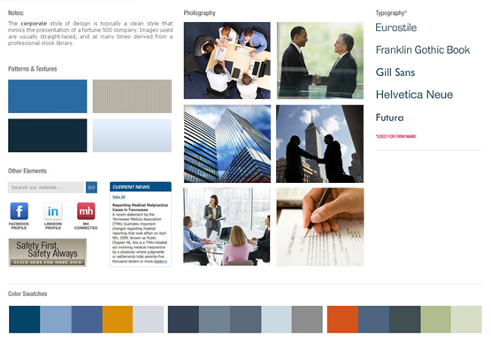

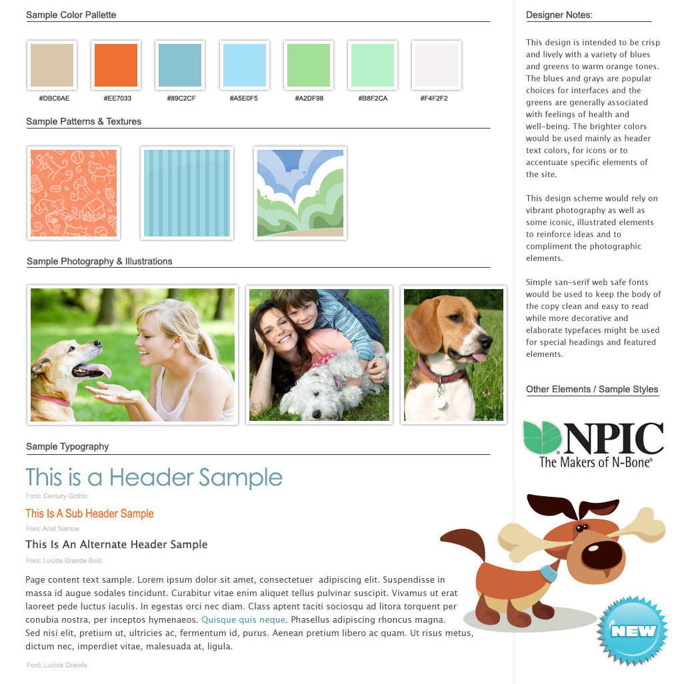

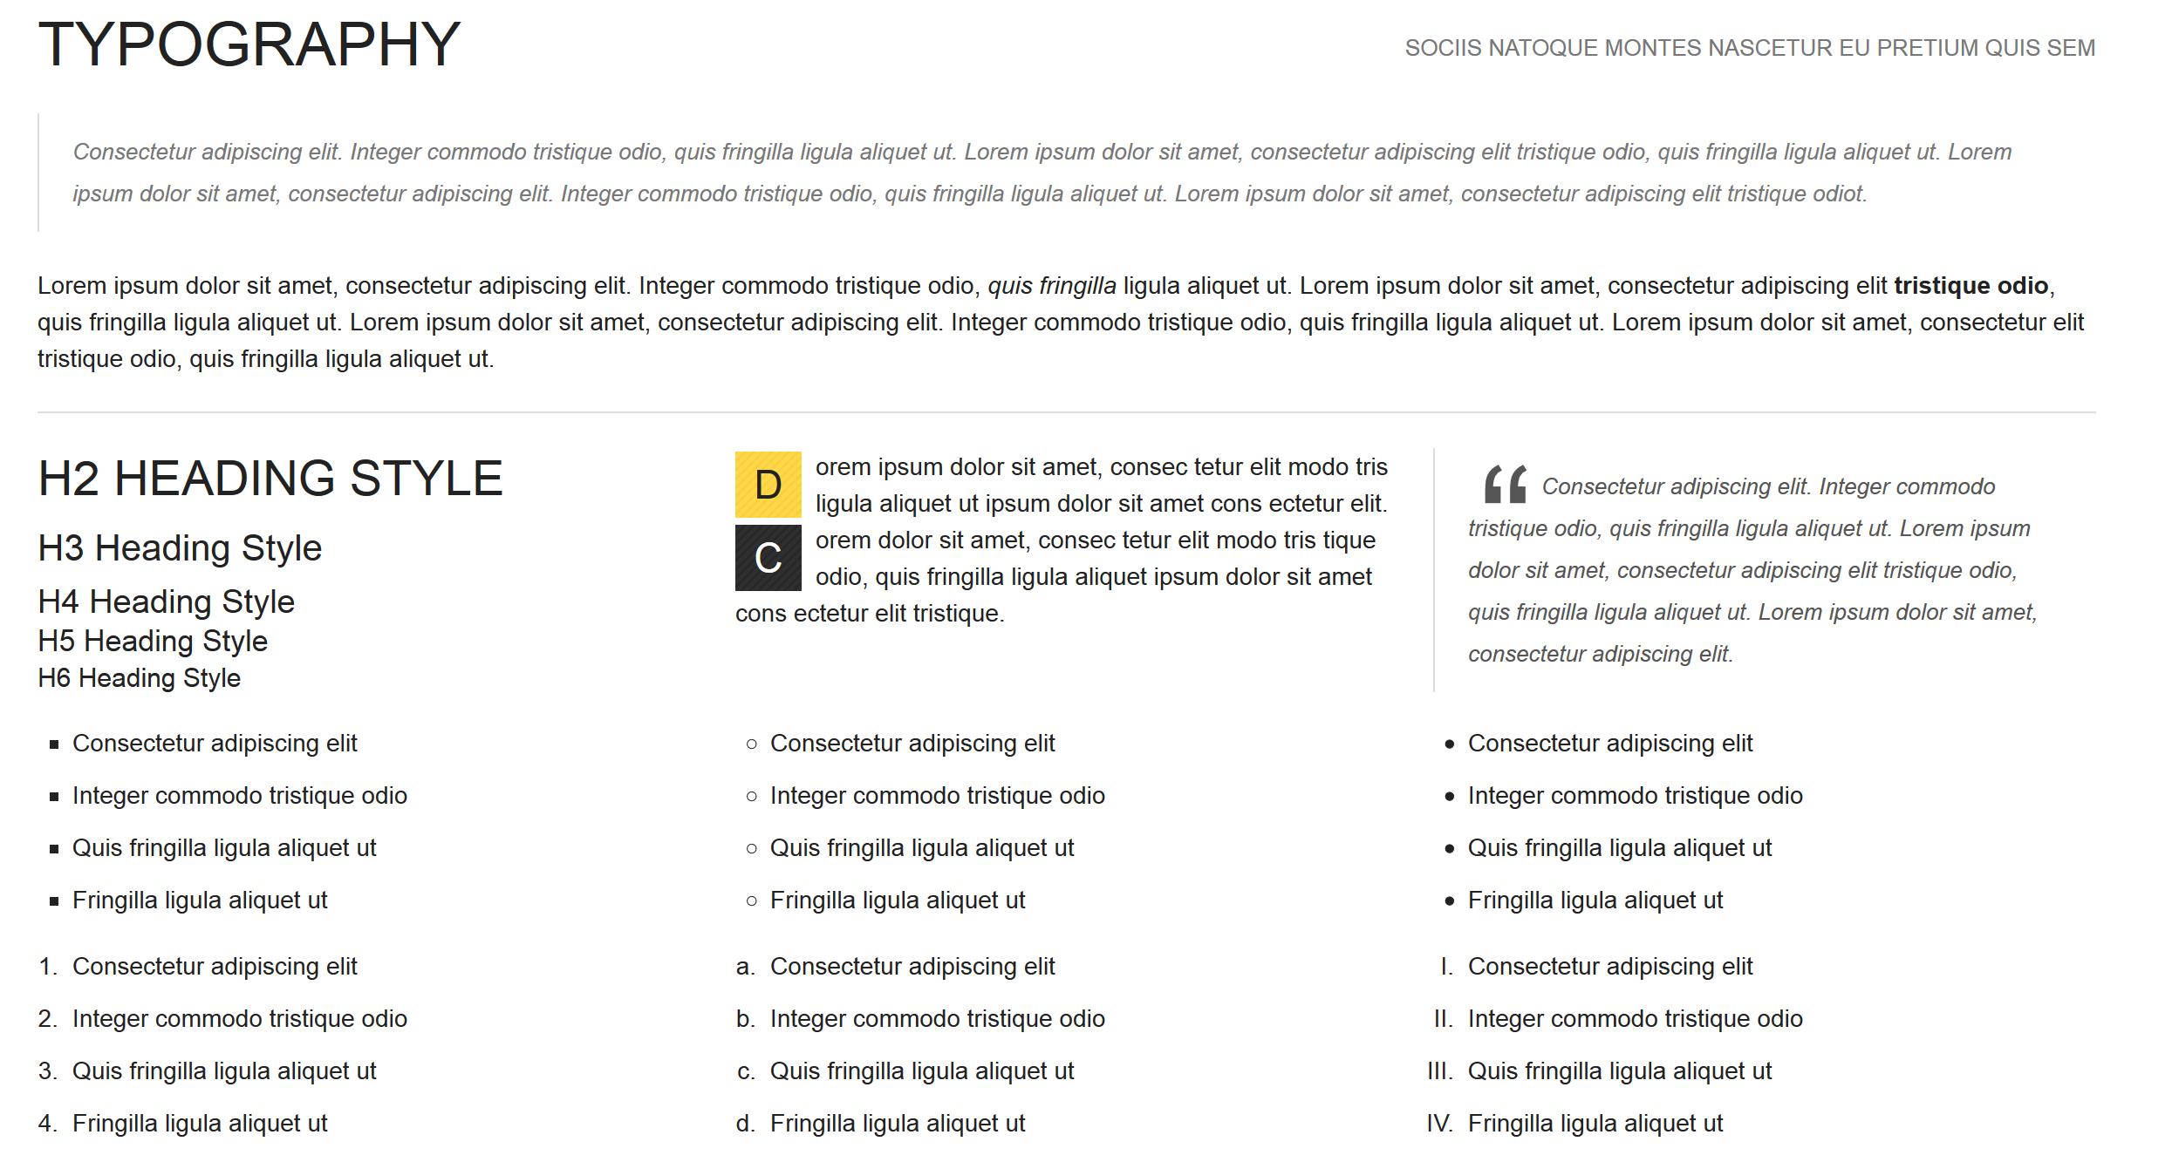

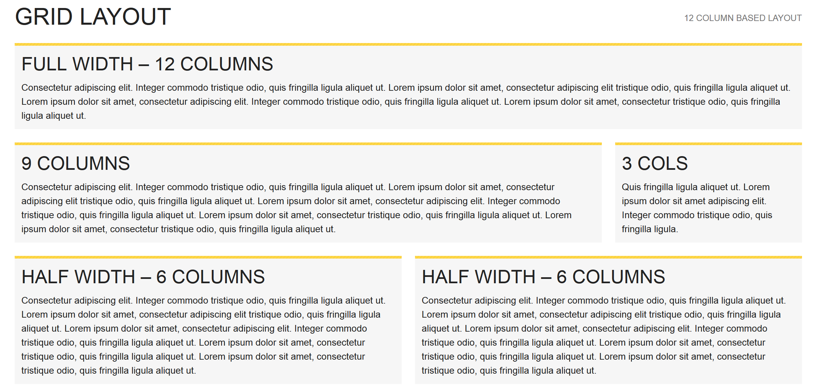

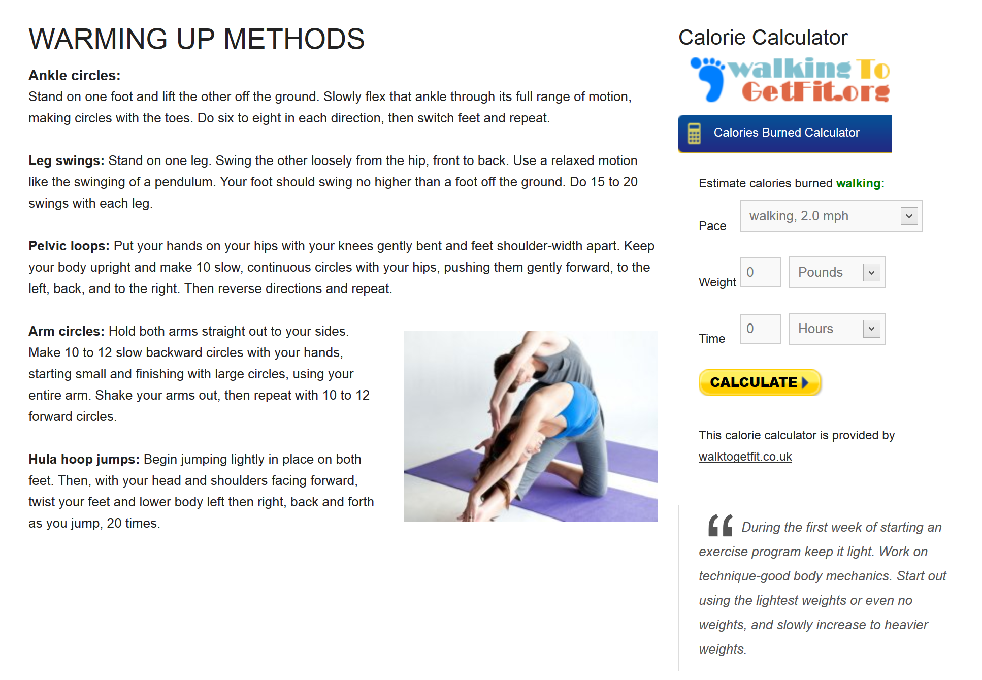

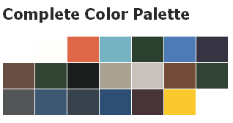

Storyboard:

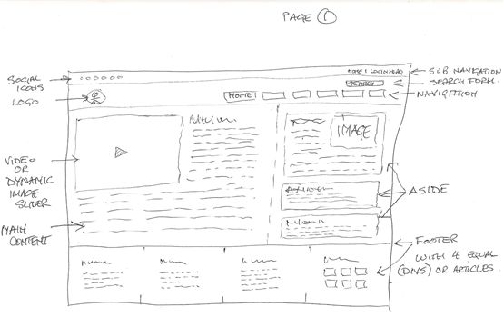

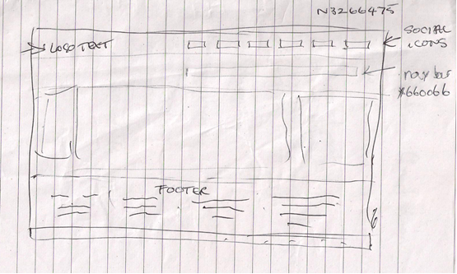

Navigation Chart:

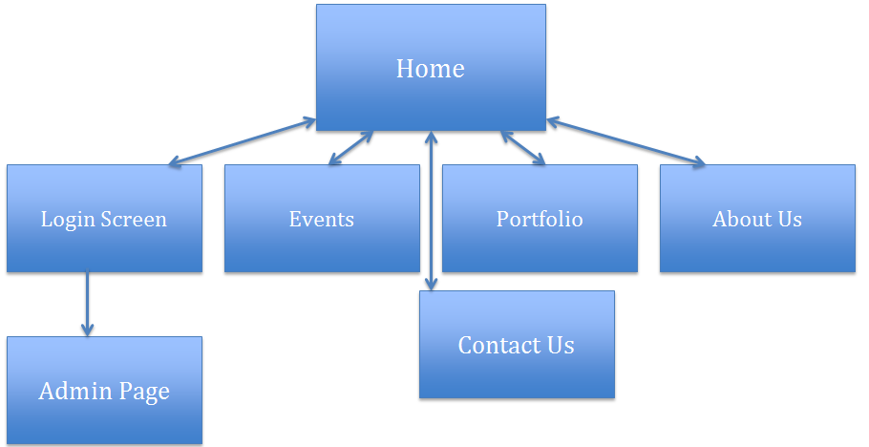

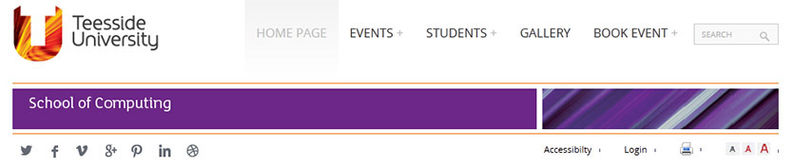

Testing plan

Group Evaluation
After several meetings with our client over a period of 4 weeks, the team decided to have a meeting to discuss what was said and to decide the way ahead. It became clear to us that we had our work cut out. And so each team member set about their individual tasks. Each and every one of this team put in 100% and should be proud of themselves for the team have produced an excellent web presence for our client, as the work needed to put this project together could have only been achieved with total team work and effort.

APPENDIX A

Desktop site
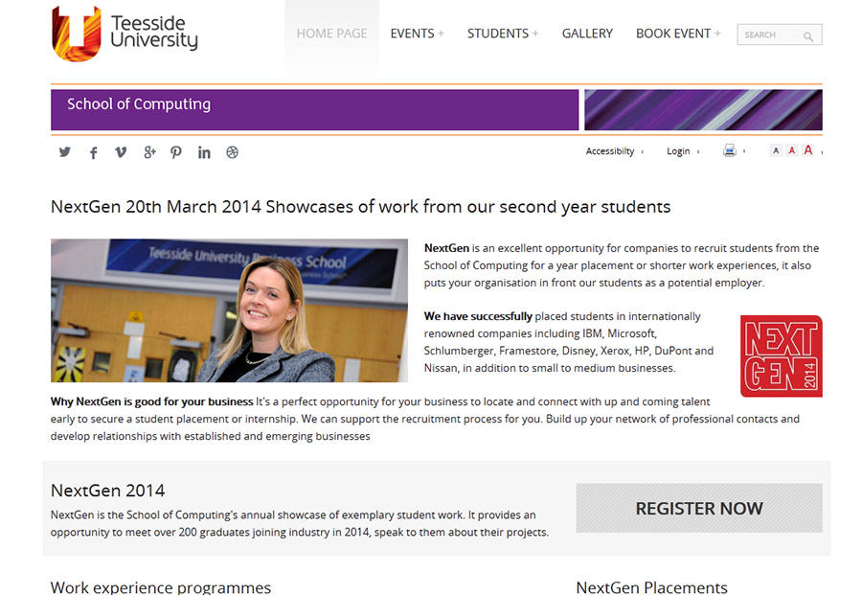

Mobile site


