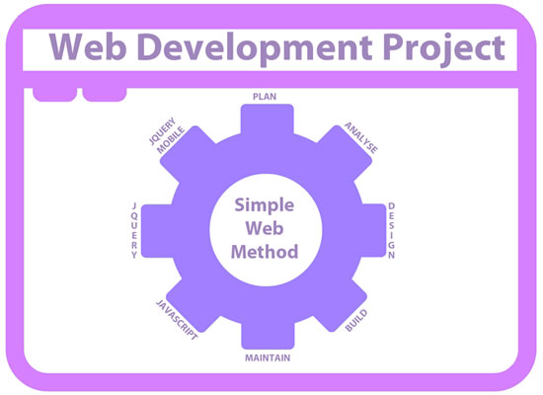

NextGen 2014
Alpha Testing Plan

Testing Information
Tester: | Stephen Walker n3266475
Work being tested: | NextGen 2014
Link to site testing: | https://scm-intranet.tees.ac.uk/
Browser used: | Mozilla Firefox 26.0
Computer used: | Dell AMD1.24Ghz Hard Drive 1GIGram
Monitor size used: | 20in Display 1280x1024

Verify Hyperlinks

Test | Action | Expected | Pass / Fail | Possible Amendments
Hyperlinks on index page | Hover over links, click event | Link changes state (colour, size etc.) links to another page | pass | No amendments needed
Hyperlinks on events page | Click event on links | Takes the user to other pages | pass | ALL LINKS WORKING NO AMENDMENTS NEEDED
Hyperlinks on gallery page | Click event on images and text | A variety of links, including lightbox to open | pass | All links working and correct
Hyperlinks on Portfolio page | Click event on numerous links | To navigate within the page also some external links | pass | No amendments needed
Hyperlinks on profile page | Hover over links to navigate within page | Link changes state (colour, size etc.) navigate within page | pass | Works well
Hyperlinks on register page | Click event on register form | Takes user to contact page | pass | Working well, no amendments needed
Hyperlinks on Login page | Hover and click event | Takes user to private area | pass | No amendments needed
Hyperlinks on FAQ page | Click event | Navigate to other pages | pass | No amendments needed

Screen Resolution Responsiveness

Test | Action | Expected | Pass / Fail | Possible Amendments
Desktop version works | Keep at desktop resolution | Everything displays as normal | pass | Could use 1044px width
Tablet version works | Resize to a tablet screen size | UI objects realign and resize to fit the smaller screen | pass | Text could be smaller
Mobile version works | Resize to a mobile screen | UI objects realign and resize and menu adjusts | pass | No ammendments needed

Readability of Text

Test | Action | Pass / Fail | Amendments
Is page text clear and readable against background | Get group feedback on readability | pass | Possible amendments are to use different font
Header and Footer content text clear and readable | Get group feedback on readability | pass | No amendments needed
Does text resizing work | Get group feedback on readability | pass | Works well
Does text in menu bar stand out clear | Get group feedback on readability | pass | Works well against background

Graphic Formats and UI Objects

Graphics Used | Comments
Image aligned left with text to the right | Graphics used are appropriate for web use
Image aligned right with text to the left | Looks good and works well when viewed on smaller devices
Image Formats Used | JPG, PNG and GIF formats have been used in the web site
Broken Graphics or Links | No broken graphics found

HTML5 Validation Results
As validated on http://validator.w3.org/ by direct input and the results written below

PASS

- Using experimental feature: HTML5 Conformance Checker.
The validator checked your document with an experimental feature: HTML5 Conformance Checker. This feature has been made available for your convenience, but be aware that it may be unreliable, or not perfectly up to date with the latest development of some cutting-edge technologies. If you find any issues with this feature, please report them. Thank you.

Congratulations
The document located at <https://scm-intranet.tees.ac.uk/users/n3266475/nextgen//index.html> was successfully checked as HTML5. This means that the resource in question identified itself as "HTML5" and that we successfully performed a formal validation of it. The parser implementations we used for this check are based on validator.nu (HTML5).

Linking to this result
If you would like to create a link to this page (i.e., this validation result) to make it easier to revalidate this page in the future or to allow others to validate your page, the URI is <http://validator.w3.org/check?index.html> (or you can just add the current page to your bookmarks or hotlist)

